**User manuals**

1. In this part, users need to input the location of source codes.



Figure5.1 The first requirement to users

1. In this part, users need to input the location of the test suite.



Figure5.2 The second requirement to users

1. In this part, users need to choose an oracle. There are three choices: 1.Human juedgement 2.Fixed-answer judgement 3.Special judgement. For python source code, it is suggested to use choice 1 or 3; for cpp source code, it is suggested to use choice 2 or 3.

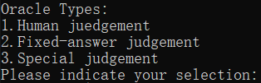

Figure5.3.1 The third requirement to users



Figure5.3.2 The progress bar for running test cases:

1. In this part, users need to choose a debugging tool. There are five debugging tools: 1. Tarantula 2. Crosstab 3. Jaccard 4. Ochiai 5. Radio basis function. And users can also choose ‘e’ to exit the program



Figure5.4.1 The fourth requirement to users:

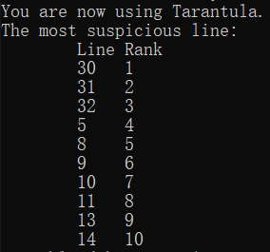

Figure5.4.2 Example output of using Tarantula debugging tools

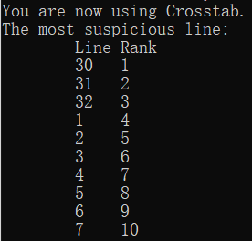

Figure5.4.3 Example output of using Crosstab debugging tools

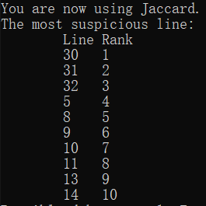

Figure5.4.4 Example output of using Jaccard debugging tools

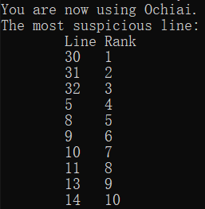

Figure5.4.5 Example output of using Ochiai debugging tools

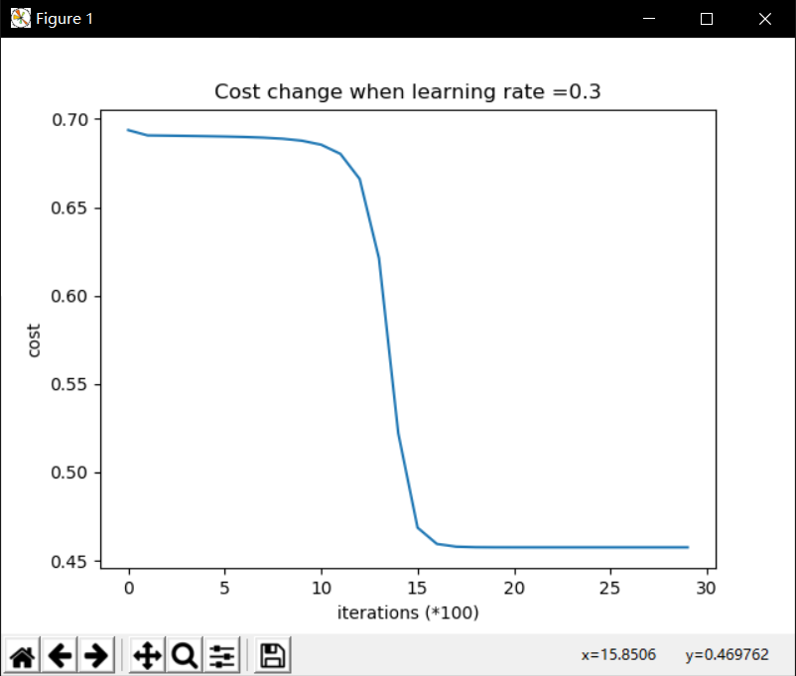

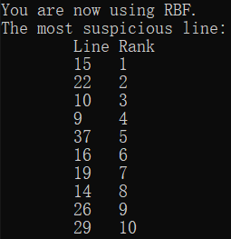

Figure5.4.6 Example output of using RBF debugging tools